Ford F-600 w/ Warner 8K Crane Body and Liftmoore 8045

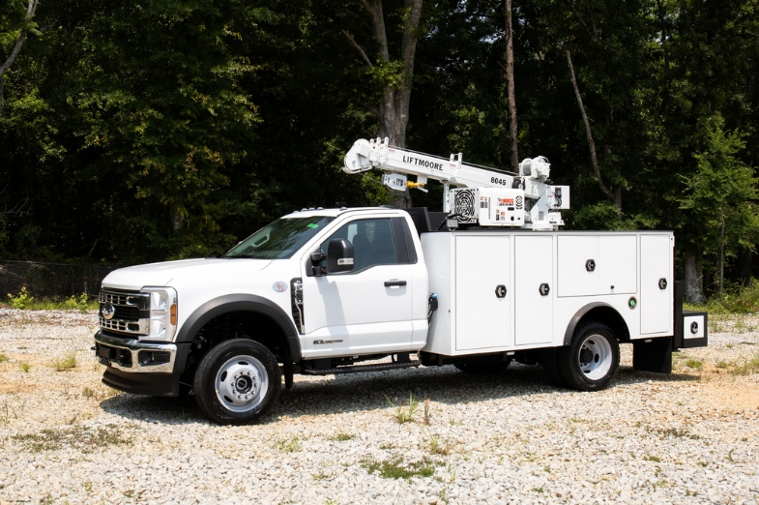 |  | 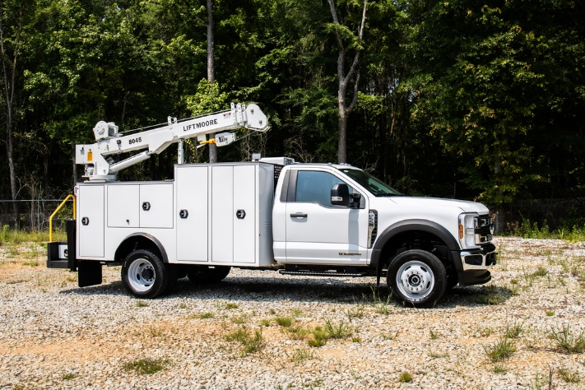
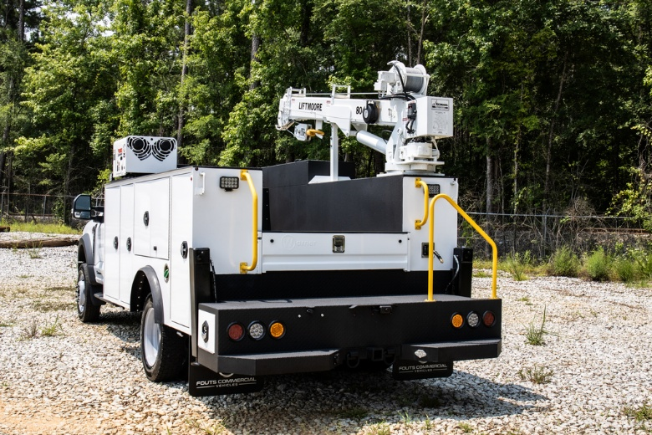 |  | 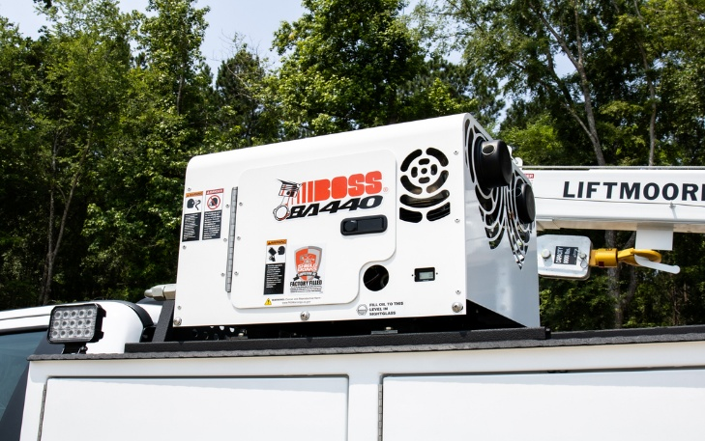

Ford F-600 w/ Warner 8K Crane Body and Liftmoore 8045

Informational Overview

- 2024 Ford F-600
- 4x4
- 6.7l V-8 Diesel Engine
- 10 Speed Automatic Transmission
- GVWR………………………….…………….22,000 Lbs.
- Warner Select 8k Crane Body-50k Ft Lbs
- CTech Drawer Packs & Bolt Bins
- Liftmoore 8045 8k Crane
- Continuous Rotation
- 45,000 Ft Lbs / 8000 Lbs @ 4 Ft
- Power Elevation From -5 Degrees To 75 Degrees
- Power Extension From 10 Ft – 22 Ft
- Boss BA 440 40 CFM
- Full Hydraulic Compressor
- Optional Features Available Upon Request

Crane Specifications

- Model 8045DX Is Designed, Tested, And Manufactured in Accordance With ASME B30.5 And OSHA 1910.180
- Max Capacity: 8,000 Lbs.
- Max Moment Rating: 45,000 Ft.-Lbs
- Hoist Winch: Planetary Gear Design w/ a 4,000 Lbs Single Line, First Layer Capacity
- Wire Rope & Sheaves: Crane is Supplied W/ 3/8” Galvanized Aircraft Cable
- Wireless Proportional Controls w/ Onboard Wifi Diagnostics And Histogram
- Wifi Diagnostics & Histogram- Wifi Feature can be Accessed w/ Any Device that has Wifi and a Web Browser
- All Crane Functions are Hydraulically Powered by an Externally Driven Hydraulic Pump
- Unlimited Rotation is Provided on a Ball Slewing Ring Type Bearing w/ an External Gear Driven by a Worm Gearbox
- Boom is Capable of Operating from -5 To +75 Degrees
- Boom Extends Hydraulically from a Minimum of 10 to 22 Feet
- Transducer Included
- 8045DX Includes an Anti-Two Block Feature that Prevents Contact Between the Boom Tip and Traveling Block
- Four 7/8” Grade 8 Hex Head Bolts are Required for Mounting. Base Plate is 17.5 X 17.5”

UNIT PRICE: $181,900.00

We sincerely appreciate the opportunity to present our products to you. We are proud of our reputation for supplying the highest quality products and services and delivering it to our customers in a timely fashion. We look forward to your favorable consideration as your supplier.

$1,000 non-refundable deposit required to secure purchase, it will be applied towards the purchase. Please sign and return to proceed.

Order Accepted By: _______________________________________________

Federal ID: ____________________ Date: _____________________

Price Valid: 30 days from Quote date.
Delivery: In Stock (Subject To Prior Sale)

If you have any questions or concerns, feel free to give me a call. Thanks for the opportunity to quote your equipment needs.

Sincerely,
Donnie Arbuckle
Donnie Arbuckle,
President
TERMS AND CONDITIONS

- This proposal supersedes any other offered by SS Utility Group, Inc (SSUG)

- In preparation of this proposal, SS Utility Group, Inc. (SSUG) has made every reasonable attempt to comply with the user’s specifications or, where necessary, provided alternative solutions. Purchasers are required to review the specifications detailed in the proposal to verify compliance with their specific needs.

- SS Utility Group, Inc. (SSUG) makes every effort to honor pricing from quotation through completion while meeting the delivery commitments we provide. Unfortunately, if a chassis, body, or aerial device manufacturer fails to deliver the bare chassis, body, aerial device, or accessory to our facility, we cannot deliver the finished product. Recent inconsistencies within the marketplace have forced us to include this disclaimer with every proposal:

If a chassis, body, or aerial device manufacturer experience delays in production for any reason, SSUG cannot be held responsible for the delayed completion of the vehicle. Furthermore, if a chassis, body, or aerial device manufacturer assesses a price increase and/or raw material surcharge on their products, SSUG will be forced to pass the associated increase on to the buyer. In the event this becomes necessary, SSUG will notify the client immediately to determine the best course of action.

- Escalation Clause For Materials: This proposal has been calculated based on current prices for component materials. However, the market for steel materials or material shortages that are hereafter specified is volatile, and sudden price increases could occur. SSUG agrees to exhaust our best efforts to obtain the lowest possible prices from available suppliers. However, should there be an increase in the prices of these specified materials that are purchased after execution of a purchase order or signed sales agreement for this unit, the Purchaser agrees to pay that cost increase to the supplier.

- This proposal is valid for 30-days from the date of issuance, unless otherwise specified in the proposal.

- This proposal does not include applicable sales tax, title, or registration fees. If tax exempt, please include a copy of the certificate when the order is placed.

- Terms of payment are Due Upon Receipt unless otherwise specified. Payment must be received in full before the Certificate of Origin (MSO/MCO) can be released. Special credit terms are available and must be established at the time the order is placed.

- Warranties: Goods are sold only with such warranties as may be extended by the manufacturer of the product. WE MAKE NO OTHER WARRANTY AND THERE ARE NO IMPLIED WARRANTIES OF MERCHANTABILITY OR FITNESS.

